**PROJECT PHASE– 2**

**FlyAway A Ticket Booking Portal Application in JAVA - Servlet&JSP**

**Project details:**

**FlyAway is a ticket-booking portal that lets people book flights on their website.**

**Developer detail’s:**

**https://github.com/Mayuri-1998/ProjectPhase2.git**

This Project is Developed by Mayuri Ahire . This project is hosted on git repository:

Table of contents

• General info

• Using the application

• Technologies Used

General Info

FlyAway is a ticket-booking portal that lets people book flights on their website. Using the application

Home page displays options to Book Flight, Customer Login and Admin Login.

Book Flight -

• User enters details such as (Source, Destination, Date of travel)

• After entering details user seletcs flight to book

• User is asked to regiter on the website if user is new or user can login into already existing account

• User is sent to a dummy payment page after confirming booking details for the payment

• After confirming paymnet user is shown the booked ticket details which user can print if they wish to

**Customer Login** -

• Customer can login into website with the details entered at the time of resitration • If the details provided are correct the user is sent to Customer Details page

• In Customer Details Page User can see list of their previous booking and also can change password if they wish to

• Customer details page also has the option to book flight if they wish to book a new journey

**Admin Login** -

• Admin can login into website with their details

• If the details provided are correct admin is sent to Admin Details Page • In Admin details page admin can see list of all the available flights

• Admin also has the option to Add a new flight and fare related details • Admin can also change their password if they wish to

Technologies Used

**Frontend** - HTML, CSS,JSP

**Backend** - JAVA Servlets

**Database** - MySQL

**Application Server** - Tomcat 8.5

✧ **SCREENSHOTS OF OUTPUT:**

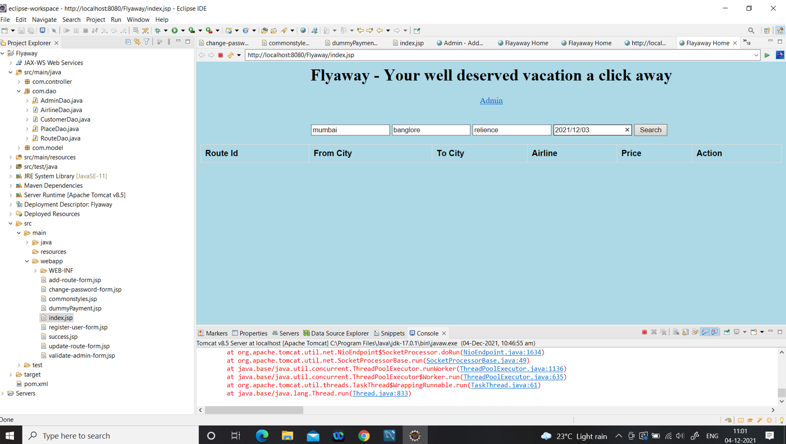✧ **WELCOME SCREEN:**

